**Unit 1:**

**Demand:**

The general meaning of the word ‘demand’ is desire. However, mere desire to have a thing does not mean demand in economics. We all have desires to have so many things, but we can have the things that we desire only if we are willing to pay for them. Our willingness to pay also depends on our capacity for it. In other words we can say that demand for a commodity or service is a desire backed by means as well as willingness to pay for it.

Demand arises out of the following three things:

1. Desire or want of the commodity.
2. Ability and willingness to pay.
3. Purchasing power to buy.

Definition of Demand:-“Demand for a commodity is the quantity which a consumer is willing to buy at a particular price at a particular time.”

**Determinants or Factors Affecting Demand:**

1. **Price of a commodity**

Demand for a commodity depends on its price. As prices for a normal good, demand falls and vice versa.

**2. Price of related goods**

The demand for a good or service not only depends on its own price but also on the price of related goods. Two items are said to be related to each other if the change in price of one item affects the demand for the other item. Related goods can be categorized as follow

* **Substitute or competitive goods:**These goods can be used interchangeably as they serve the same purpose; thus, are the competitors of each other.  
    
  For example, tea and coffee. The increase in price of tea would decrease its quantity demanded and people would switch over to its substitute commodity coffee.
* **Complementary goods**: Complementary goods are used jointly and consumed together. There is an inverse relationship between the demand and price of complementary goods. This implies that an increase in the price of one good will result in fall in the demand of the other good.  
    
  For example,car and petrol. An increase in the price of petrol would lower the demand for cars.
  1. **Income of consumers**

The level of income of individuals determines their purchasing power. Generally, income and demand are directly proportional to each other. This implies that rise in the consumers’ income results in rise in the demand for a commodity.

* 1. **Tastes and preferences of consumers**

The demand for commodity changes with changes in the tastes and preferences of consumers (which depend on customers’ customs, traditions, beliefs, habits, and lifestyles).  
  
For example, the demand for burqas is high in gulf countries. In such countries, there may be less or no demand for short skirts.

* 1. **Consumers’ expectations**

Demand for commodities also depends on the consumers’ expectations regarding the future price of a commodity, availability of the commodity, changes in income, etc. Such expectations usually cause rise in demand for a product.  
  
For example, if a consumer expects a rise in the price of a commodity in the future, he/she may purchase larger quantities of the commodity in order to stock it. Similarly, if a consumer expects a rise in his/her income, he/she may purchase a commodity that was relatively unaffordable earlier.

* 1. **Population Size:**

Population size refers to the actual number of individuals in a population. An increase in the size of a population increases the demand for commodities as the number of consumers would increase.

* 1. **Climatic factors**

The demand for commodities depends on the climatic conditions of a region such as cold, hot, humid, and dry.  
  
For example, the demand for air coolers and air conditioners is higher during summer while the demand for umbrellas tends to rise during monsoon.

* 1. **Government policy**

This includes the actions taken by the government to determine the fiscal policy and monetary policy such as taxation levels, budgets, money supply, and interest rates. Government policies have direct impact on the demand for various commodities.  
  
**For example**, if the government imposes high taxes (sales tax, VAT, etc.) on commodities, their prices would increase, which would lead to a fall in their demand.

**Law of Demand:**

The law of demand describes the relationship between quantity demanded and the price. It tells us what happens to the demand for a commodity when its price changes. In other words, the law of demand shows the direction of demand for a commodity due to change in its price.

The law can be stated in the following words: “other things remaining constant, the quantity demanded of a commodity increases with a fall in price and declines with a rise in price.” This means that a fall in price will lead to an expansion of quantity demanded whereas a rise in price leads to a fall in quantity demanded.

## **Assumptions of Law of Demand**

The law of demand follows the [assumption of ceteris paribus](https://www.geektonight.com/law-of-demand/#assumptions-of-law-of-demand), which means that the **other factors remain unchanged** or constant.

As mentioned earlier, the demand for a commodity or service not only depends on its price but also on several other factors such as price of related goods, income, and consumer tastes and preferences.

In the law of demand, other factors are assumed to remain constant while only the price of the commodity changes.

**Following are the**[assumptions of law of demand](https://www.geektonight.com/law-of-demand/#assumptions-of-law-of-demand)**:**

1. [No expectation of future price changes or shortages](https://www.geektonight.com/law-of-demand/#no-expectation-of-future-price-changes-or-shortages)
2. [No change in consumer’s preferences](https://www.geektonight.com/law-of-demand/#no-change-in-consumers-preferences)
3. [No change in the price of related goods](https://www.geektonight.com/law-of-demand/#no-change-in-the-price-of-related-goods)
4. [No change in consumer’s income](https://www.geektonight.com/law-of-demand/#no-change-in-consumers-income)
5. [No change in government policy](https://www.geektonight.com/law-of-demand/#no-change-in-government-policy)

### Demand Schedule

A demand schedule is a tabular statement that shows different quantities of a commodity that are demanded at different prices, over the course of a particular time period. Therefore there are two types of demand schedules:

1. Individual Demand Schedule
2. Market Demand Schedule

#### 1. Individual Demand Schedule

The tabular statement that shows different quantities of a commodity that an individual consumer demands at different levels of prices during a given time period is referred to as the **Individual Demand Schedule**.

**Example:**

**Individual Demand Schedule**

| **Price (in ₹)** | **Quantity Demanded of commodity x (in units)** |
| --- | --- |
| 10 | 20 |
| 9 | 21 |
| 8 | 22 |
| 7 | 23 |
| 6 | 24 |
| 5 | 25 |

As shown in the above schedule, with the decrease in the price of commodity x, the quantity demanded increases. The consumer is willing to buy 20 units at ₹10, and when the price drops to ₹9, demand increases to 21 units. Thus with the decrease in the price to ₹8, ₹7, ₹6, and ₹5, the demand increases to 22, 23, 24, and 25 units, respectively.

#### 2. Market Demand Schedule

The tabular statement that shows different quantities of a commodity that all the consumers are willing and capable to purchase at different levels of prices during a given time period is referred to as the **Market Demand Schedule**.

**Example:**

**Market Demand Schedule**

| **Price of Oranges (in ₹)** | **Quantity of Oranges Demanded (in kg)** |
| --- | --- |
| 15 | 4000 |
| 12 | 5000 |
| 9 | 6000 |
| 6 | 7000 |
| 3 | 8000 |

**Demand Curve:**

The demand curve is a diagrammatic representation of a demand schedule.

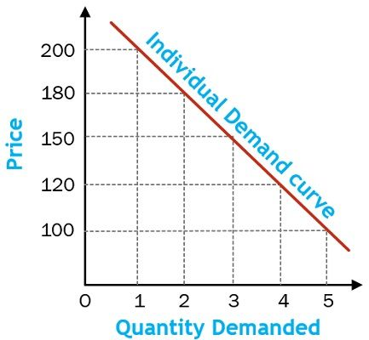

**Note: Always remember to explain your demand schedule and demand curve in your answers.**

**Exceptions to the Law of Demand:**

### Giffen goods

A Giffen good is an inferior good consumed mainly by poor people. [Sir Robert Giffen](https://en.wikipedia.org/wiki/Robert_Giffen) observed that when the price of bread fell, the English workers did not increase their consumption of bread but used the money income saved to purchase more meat. The income effect of the fall in the price of bread was an increase in the demand for meat. Hence, the law of demand was not applicable in case of bread which was considered to be an inferior good by the workers.

1. **Articles of distinction goods/Prestige Goods/Veblen Goods**

Named after economist, Thorstein Veblen, these commodities satisfy the desires of the upper-class people in society. Veblen goods include those commodities whose demand is proportional to their price and thus, they are exceptions to the law of demand.These articles are purchased only by a few rich people to feel superior to the rest. For example, diamonds, rare paintings, vintage cars, and antique goods are examples of Veblen goods. These goods will be demanded more even at a higher price and demanded less at a lower price.

### Consumers ignorance

Consumer ignorance is another factor that motivates people to purchase a commodity at a higher price, which violates the law of demand. This results out of the consumer biases that a high-priced commodity is better in quality than a low-priced commodity.

### Situations of crisis

Crisis such as war and famine negate the law of demand. During crisis, consumers tend to purchase in larger quantities with the purpose of stocking, which further accentuates the prices of commodities in the market. They fear that goods would not be available in the future.

On the other hand, at the time of depression, a fall in the price of commodities does not induce consumers to demand more.

### Future price expectations

When consumers expect a rise in the prices of commodities, they tend to purchase commodities at existing high prices. For example, speculation of market strategists on an increase in gold prices in the future induces consumers to purchase higher quantities in order to stock gold.

On the contrary, if consumers expect a fall in the price of a commodity, they postpone the purchase for the future.

#### **Expansion and Contraction in Demand:**

#### **1. Expansion in Demand**

When there is an increase in the quantity demanded of a commodity because of a fall in its price by keeping other factors constant, it is known as an Expansion in Demand. Expansion in demand results in a downward movement along the same demand curve. It is also known as an Extension in Demand or Increase in Quantity Demanded.

#### **2. Contraction in Demand**

When there is a fall in the quantity demanded of a commodity because of an increase in its price by keeping other factors constant, it is known as Contraction in Demand. Contraction in demand results in an upward movement along the same demand curve. It is also known as a Decrease in Quantity Demanded.

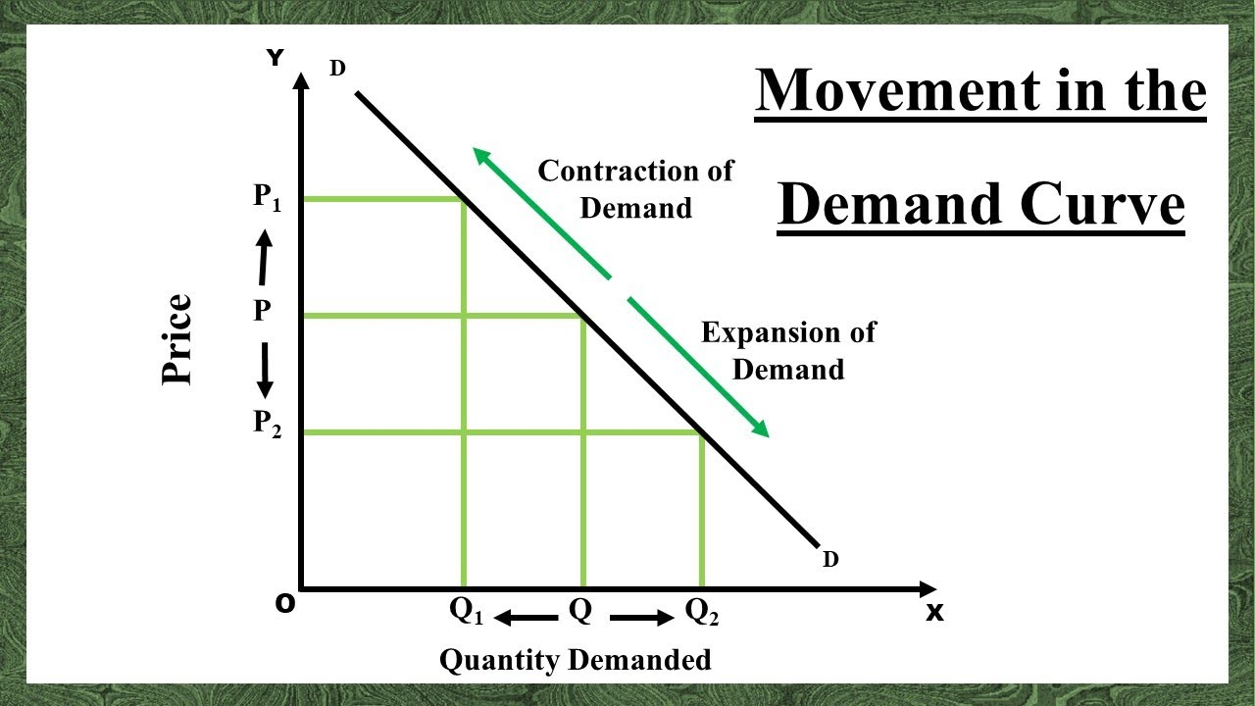

**Increase and Decrease in Demand:**

#### **1. Increase in Demand**

When there is an increase in the quantity demanded of a commodity because of any factor other than the price of the commodity, it is known as an Increase in Demand. In simple terms, the demand for a commodity increases at the same price, because of changes in other factors. An increase in demand results in a rightward shift in the demand curve.

#### **2. Decrease in Demand**

When there is a fall in the quantity demanded of a commodity because of any factor other than the price of the commodity, it is known as Decrease in Demand. In simple terms, the demand for a commodity decreases at the same price, because of changes in other factors. A decrease in demand results in a leftward shift in the demand curve.

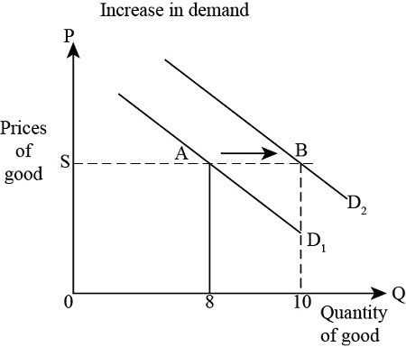

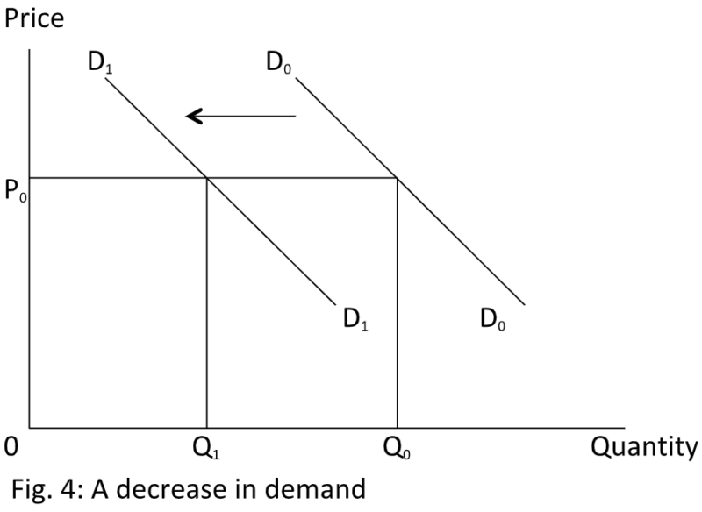

**Elasticity of Demand:**

### Price Elasticity of Demand

[**Price elasticity of demand**](https://www.geektonight.com/price-elasticity-of-demand/#what-is-price-elasticity-of-demand) is a measure of a change in the quantity demanded of a product due to change in the price of the product in the market.

#### [**Types of Price Elasticity of Demand**](https://www.geektonight.com/types-of-price-elasticity-of-demand/#types-of-price-elasticity-of-demand)

There are basically 5 [types of price elasticity of demand](https://www.geektonight.com/types-of-price-elasticity-of-demand/#types-of-price-elasticity-of-demand):

1. [**Perfectly Elastic Demand**](https://www.geektonight.com/price-elasticity-of-demand/#perfectly-elastic-demand)
2. [**Perfectly Inelastic demand**](https://www.geektonight.com/price-elasticity-of-demand/#perfectly-inelastic-demand)
3. [**Relatively Elastic Demand**](https://www.geektonight.com/price-elasticity-of-demand/#relatively-elastic-demand)
4. [**Relatively Inelastic Demand**](https://www.geektonight.com/price-elasticity-of-demand/#relatively-inelastic-demand)
5. [**Unitary Elastic Demand**](https://www.geektonight.com/price-elasticity-of-demand/#unitary-elastic-demand)

### Perfectly Elastic Demand (Ed=∞)

When a small change (rise or fall) in the price results in a large change (fall or rise) in the quantity demanded, it is known as [perfectly elastic demand](https://www.geektonight.com/types-of-price-elasticity-of-demand/#perfectly-elastic-demand).

### Perfectly Inelastic Demand (Ed=0)

When a change (rise or fall) in the price of a product does not bring any change (fall or rise) in the quantity demanded, the demand is called [perfectly inelastic demand](https://www.geektonight.com/types-of-price-elasticity-of-demand/#perfectly-inelastic-demand).

### Relatively Elastic Demand (Ed>1)

When a proportionate or percentage change (fall or rise) in price results in greater than the proportionate or percentage change (rise or fall) in quantity demanded, the demand is said to be [relatively elastic demand](https://www.geektonight.com/types-of-price-elasticity-of-demand/#relatively-elastic-demand).

### Relatively Inelastic Demand (Ed<1)

When a percentage or proportionate change (fall or rise) in price results in less than the percentage or proportionate change (rise or fall) in demand, the demand is said to be [relatively inelastic demand](https://www.geektonight.com/types-of-price-elasticity-of-demand/#relatively-inelastic-demand).

### Unitary Elastic Demand (Ed=1)

[Unitary elastic demand](https://www.geektonight.com/types-of-price-elasticity-of-demand/#unitary-elastic-demand) occurs when a change (rise or fall) in price results in equivalent change (fall or rise) in demand.

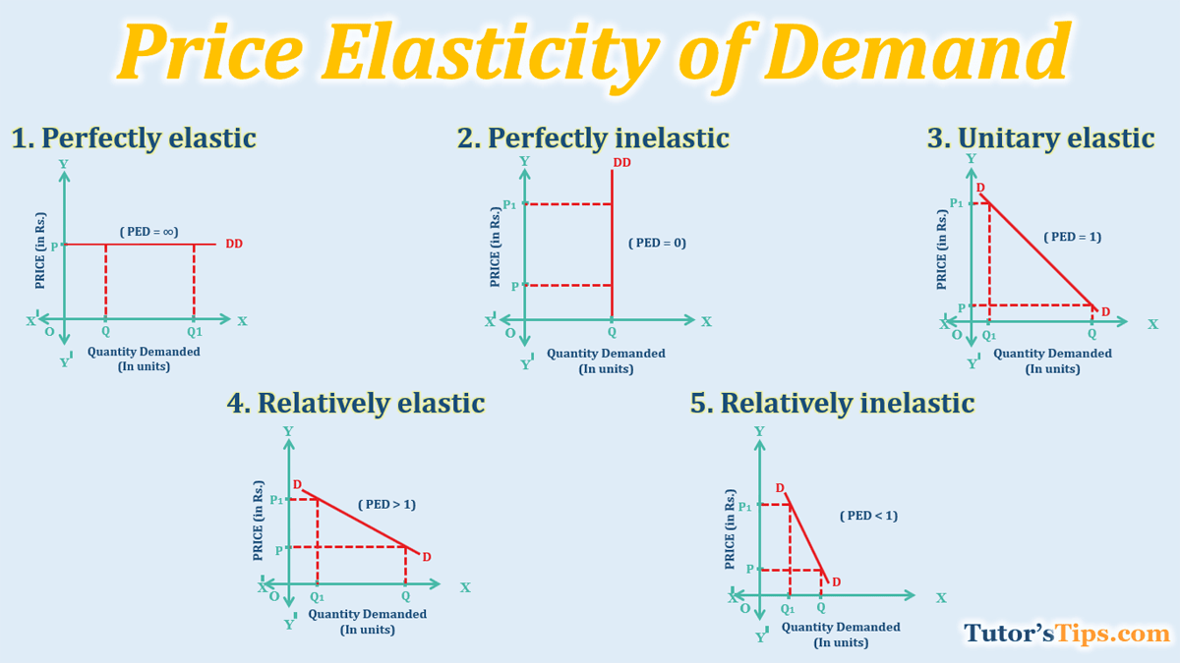

**Supply**

Supply means the quantities of a commodity or service which a seller is willing and able to offer for sale at different prices during a given period of time. It is obvious that if the price goes up, he will offer more for sale but if the price goes down, he will be reluctant to sell and will offer to sell less. Therefore, the relation between price and quantity supplied is direct and positive.

**Supply and Stock**

The words supply and stock of the commodity are frequently used interchangeably. However, the two concepts are different in economics.

Supply implies the various quantities that a seller is willing and is able to offer for sale at a given price. Or supply is the actual quantities which are available for sale in the market at a given price. Thus supply does not include the entire stock of a commodity produced by the firm or industry but only that amount which is available for sale.

Stock on the other hand refers to the quantity which a seller or producer can offer for sale at an acceptable price. Thus stock implies the quantity which a seller or producer can transform into supply if he wishes to or if the condition is favorable. It is on this ground that stock is also known as potential supply.

**Factors influencing the supply of a commodity:**

#### **1. Price of the given Commodity:**

The price of a commodity is the main factor affecting its supply. A commodity's price and supply are typically directly correlated with one another. It indicates that as the price of a specific commodity rises, the quantity supplied also increases and vice versa. It occurs because there are greater chances of making a profit at higher prices. It encourages the company to increase the number of goods it sells in the market.

#### **2. Price of other Goods:**

The supply of a particular commodity is also related to the price of other commodities. Let us assume that goods A and B are close substitutes. An increase in the price of good A will lead to a fall in the supply of good B and vice versa. This is due to the fact that rise in the price of good A will encourage producers to produce more of good A. Consequently, production of good B will fall and its supply will decline.

#### **3. Price of the Factors of Production or Inputs:**

The cost of producing a commodity is determined by the prices of the inputs or elements of production utilized in the manufacturing process. The cost of production rises if the prices of any or all of these components or inputs rise. As a result, profitability declines, because of which the seller decreases the commodity's supply. On the other hand, a rise in the profit margin based on a decrease in the price of manufacturing inputs or factors increases supply. **For instance,**baking a biscuit needs various inputs like flour, sugar, labour, machines, etc. If the price of one of more inputs rises, then baking biscuits will become less profitable, and the firm will supply less biscuits.

#### **4. State of Technology:**

The supply of a commodity is influenced by technological advancements. Advanced and proven technology lowers production costs, enhancing profit margins. It encourages the seller to increase the supply. However, due to technological degradation or complex and outdated technology, the cost of production of a firm increases resulting in a decline in supply.

#### **5. Government Policies (Tax and Concessions):**

When the government increases taxes, it increases the cost of production of the firms, resulting in a decline in supply due to lower profit margins. However, when the government provides tax deductions and subsidies, it increases the supply as it becomes more profitable for the firms to supply their goods.

#### **6. Objectives of the Firm:**

In general, the supply of a commodity increases only at higher prices since it achieves the profit maximization objective of the firms. However, because of the changing trend, some businesses are willing to supply more even at rates that do not maximize their profits. Such businesses want to expand their reach into new markets and improve their image.

**Law of Supply:**

The law of supply explains the relationship between the quantity offered for sale and the price. Thus the law states that, “Other things remaining the same, more quantity of a commodity will be offered for sale at higher price than at a lower price.” In other words, when the price of a commodity increases more quantity of a commodity will be offered for sale and vice versa.

**Assumptions of Law of Supply**

The phrase *"keeping other factors constant or ceteris paribus"* is used when describing the law of supply. This expression refers to the following presumptions that the law is based on:

1. The price of other commodities is constant.
2. The state of technology has not changed.
3. The price of factors of production is constant.
4. The taxation laws remain the same.
5. The producer's objectives are constant.

Supply Schedule:

Supply schedule is a table or a chart showing the various quantities of a commodity offered for sale at different prices in a given period of time. Supply schedule can be of two types:

1. **Individual Supply Schedule:** A table showing the relationship between the quantities supplied of a particular firm at different prices is known as Individual Supply Schedule.

|  |  |
| --- | --- |
| **Price (in Rupees)** | **Quantity (Units)** |
| 1 | 10 |
| 2 | 20 |
| 3 | 30 |
| 4 | 40 |
| 5 | 50 |

1. **Market Supply Schedule:** In a market, there is not one producer or firm but many producers of a commodity. Thus, the relationship between the quantities of the commodity offered for sale at a specified price by all producers or firms in the market dealing in that commodity in tabular form is known as Market Supply Schedule.

|  |  |  |  |
| --- | --- | --- | --- |
| **Price (in Rupees)** | **Firm A** | **Firm B** | **Market (A+B)** |
| 1 | 10 | 20 | 30 |
| 2 | 20 | 30 | 50 |
| 3 | 30 | 40 | 70 |
| 4 | 40 | 50 | 90 |
| 5 | 50 | 60 | 110 |

**Supply Curve:**

A diagrammatic representation of the supply schedule is known as supply curve. This is also of two types i.e., Individual Supply Curve and Market Supply Curve

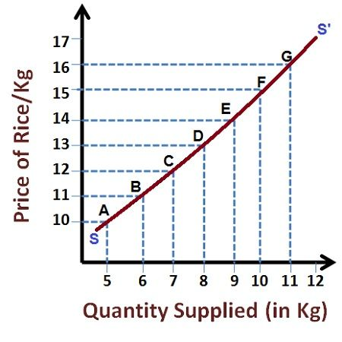

The supply curve SS’ slopes upwards from left to right which means that as the price rises, more is being offered for sale and vice versa.

## **Exceptions to the Law of Supply**

Generally, the slope of the supply curve is upwards, showing that with the rise in the price of a commodity, its quantity supplied also rises. However, there may be some cases when there is no positive relationship between the supply and price of a commodity. These cases are as follows:

### 1. Future Expectations:

The law of supply is not valid if sellers expect a fall in the price in the future. The sellers will be willing to sell more in this situation, even at a cheaper price. However, if sellers expect an increase in the future price, they will reduce supply to deliver the item later at a higher price.

### 2. Agricultural Goods:

Agricultural products are exempted from the rule of supply as they are produced in response to climatic circumstances. If the production of agricultural goods is low because of unexpected weather changes, supply cannot be expanded, even at higher prices.

### 3. Perishable Goods:

Sellers are willing to offer more perishable commodities, such as fruits, vegetables, and other foods, even if prices are dropping. This occurs because sellers cannot keep such things for an extended period.

### 4. Rare Articles:

The law of supply does not apply to precious, rare, or artistic items.For example, even if the price increases, the number of rare items like the Mona Lisa artwork cannot be increased.

### 5. Backward Countries:

Due to the scarcity of resources, output and supply cannot be enhanced in economically underdeveloped countries.

**Increase and Decrease in Supply:**

### Increase in Supply

An increase in supply refers to the increase in supply at the same price or in other words, a rightward shift of the supply curve. Various factors cause an increase in supply. If the cost of production decreases, it becomes cheaper for the producers to produce a particular good and hence to make more profit supply increases.

Technological progress also reduces the production cost causing the supply to increase. [Taxation](https://www.vedantu.com/commerce/taxation) and subsidy would also influence the supply of a good. Reduction in taxes and an increase in subsidies cause the production cost to fall and the supply to increase.

### Decrease in Supply

The decrease in supply is the complete opposite situation. A decrease in supply refers to a fall in supply at the same price or the leftward shift of the supply curve. Various factors may cause a decrease in supply.

* First and foremost, an increase in the production cost would make it more costly for the producers to produce, causing a decrease in supply.
* When the producers refuse to adopt new technology, their cost of production increases and this causes a decrease in supply.
* When taxes are increased, and subsidies reduced, it causes the supply to decrease owing to an increase in the cost of production.

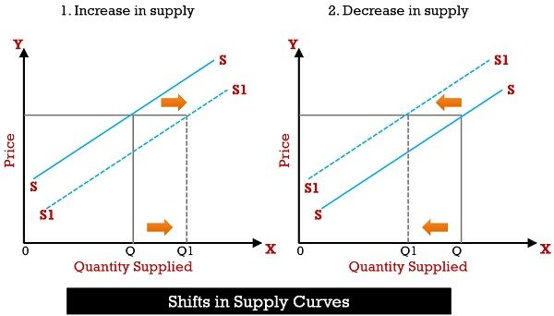

**Expansion and Contraction of Supply:**

### Extension of supply

It refers to the increase in supply of a commodity with the rise in price, other factors remaining unchanged.

### Contraction of supply

It refers to the fall in supply of a commodity when its prices fall, other factors remaining unchanged.

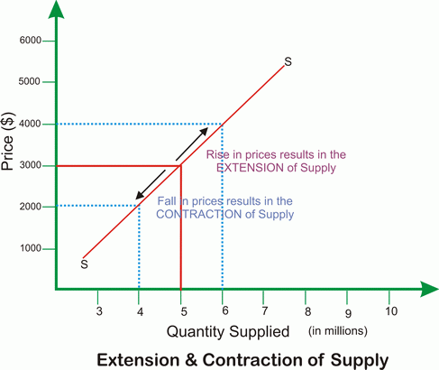

**Market Structure:**

**Meaning of Market:**

In economics, market does not refer to a particular place but it refers to a group of buyers and sellers who are in close contact with one another to finalize the transaction of sale or purchase of a commodity or group of commodities.

In other words, we can also say that market means a system or setup in which buyers and sellers of a commodity meet and strike a deal (transaction) about the price and quantity to be bought and sold.

**Market Structures:**

No two markets are exactly the same. These differ widely thus, there are different forms or structures of market. Market structure refers to the types of market in which producers or firms operate and transact business. The economists from time to time classified the various market structures as under:

1. **Perfect Competition**: Perfect competition is a market in which there are many firms selling identical product with no firm large enough relative to the entire market to be able to influence market price. The price in a perfect competitive market is determined by the total demand and total supply in the market. Each firm has to accept the price fixed by the industry. Thus, the firm is said to be a price taker and not a price maker.

Features of a Perfect Competition Market:

1. **Large number of buyers and sellers:** There are many buyers and sellers each with an insignificant share of the market- this means that each firm is too small relative to the overall market to affect price by changing its own supply and demand, so a single firm’s decision has no impact on the market price. Each individual firm must accept the market price.
2. **Existence of identical product:** The products sold under perfect competition are identical or homogeneous. There should not be any product differentiation. Since the customers perceive the products to be identical, all the sellers have to sell their product at a uniform price.
3. **Free entry and exit of firms:** There is no restriction upon the entry of a new firm in the market or upon the exit of an existing firm, which means that the market is open to competition from new suppliers.
4. **Perfect Knowledge of market:** All buyers and sellers have perfect knowledge about the existing market conditions which includes demand, supply and prices. Sellers should be aware of the price charged by other sellers in the market while buyers must have knowledge about the ruling market price so that no buyer can be charged a different price.
5. **Absence of selling and transportation cost:** Perfect competition assumes that all the producers and the purchasers of a commodity are sufficiently close to each other that no transportation cost is involved in carrying goods from one place to another.
6. **Demand Curve:** The demand curve under perfect competition is a horizontal straight line parallel to the X-axis. This indicates that the firm being a price taker can sell any amount of output at the prevailing market price.
7. **Monopoly:** Monopoly is an extreme form of market situation in which there is a single seller of a commodity which has no close substitutes. Being the sole producer of the commodity, the seller has strong control over the price prevailing in the market. Examples of monopoly can be found in local public utilities like electricity, post office, etc.

Features of a Monopoly Market:

1. **Single Seller:** For monopoly to exist there should be only one seller in the market. The producer may be an individual, a partnership firm, a joint stock company or the government
2. **Absence of close substitutes:** The product produced by the monopolist has no close substitute.
3. **Barriers to entry of firms:** The existence of monopoly implies that there are restrictions or barriers which prevent new firms from entering into the market.
4. **Price determination:** The monopolist being the only producer of the product has complete control over the supply and hence can fix the price of the product as he likes. He is, therefore, the price maker.
5. **Demand Curve:** The monopolist faces a downward sloping curve for this product which implies that the monopolist can only increase his sale by lowering the price.
6. **Monopolistic Competition:** Monopolistic competition is a market situation which is characterized by a large number of firms selling differentiated products. According to Leftwitch, “Monopolistic competition is a market situation in which there are many sellers of a particular product but the product of each seller is in some way differentiated in the minds of consumers from the product of every other seller.”

**Features of a Monopolistic Competition Market:**

1. **Large number of sellers:** There are large number of sellers producing and selling their products independently without caring for any effect which its action may have on its competitors. The firms though large in number are small in size.
2. **Product differentiation:** The product of each firm is differentiated from any other product. These products are relatively close substitutes of each other but not perfect substitutes. Sellers may bring about differentiation in their product to allure their buyers through various methods. Differences can be brought through quality of material used, design, colour, branding, packaging or advertisement. Each seller enjoys a degree of monopoly power through product differentiation.
3. **Ease of entry and exit:** New firms can enter into the industry and produce very close substitutes for the existing brands of products. The product of the new firm, however, should not be exactly the same as that of any existing firm. The firms also have the liberty to leave the industry as and when they wish.
4. **Selling Cost:** Each firm under the monopolistic competition tries to compete with other firms by promoting distinctive features of its product among the consumers through advertisement, propaganda, etc. The expenditures incurred on advertisement or selling cost are essential to push up sales.
5. **Price policy of a firm:** Unlike perfect competition, the firm under monopolistic competition has a price policy of its own. Each firm makes its price-output decision based on its cost and demand conditions.
6. **Imperfect knowledge among buyers:** Existence of imperfect knowledge among buyers about the closely related products help sellers to differentiate their products. By incurring expenditure on advertisement or publicity, a seller can actually create an imaginary superiority of its product in the minds of consumers.
7. **Non-price competition:** An important feature of monopolistic competition is the non-price competition through which firms try to attract consumers. It may be in the form of a discount, gift with a particular purchase, after sales service, free home delivery of the product, etc.
8. **Demand Curve:** The demand curve under monopolistic competition is a downward sloping curve. However, the slope of the demand curve is relatively flatter than the demand curve under monopoly. If a firm under monopolistic competition reduces the price of its product while the price of rival products remain unchanged, there would be a sizeable increase in the sales of the firm.
9. **Oligopoly:** Oligopoly is a market situation in which there are few firms selling a product which is either homogeneous or close but not perfect substitutes of each other. Example of an oligopoly market is the Telecom Industry.

**Features of an oligopolistic market:**

1. **Few sellers:** There are only a few sellers in the market each producing a product which is either homogeneous or differentiated.
2. **Interdependence of firms:** The number of firms in the oligopolistic market is small and hence each firm enjoys a large share of the market. While taking decisions with regard to price and output, each firm has to consider the reactions of other firms to its price-output policy. Thus, firms under oligopoly have a high degree of interdependence among them.
3. **Selling cost**: Firms under oligopoly incur sufficient amount of expenditure on advertisement, publicity or propaganda to influence the consumer about the product.
4. **Attitude of firms:** In an oligopolistic market, the firms may compete with each other to maximize the profits. At times, the firms realizing the disadvantage of competition may enter into a collusion to maximize their profits.
5. **Price rigidity**: Prices tend to remain rigid under oligopoly with product differentiation. If a firm reduces its price to increase its sales by attracting the customers of its rivals, it will immediately result in a similar price cut by its rivals. This will lead to a price-war which will benefit none. On the other hand, if a firm raises its price to earn more profit, it will lose some of its customers since its rivals will not react to its price policy for fear of a decrease in the sales. Hence, price once determined will tend to remain rigid under differentiated oligopoly.

**Firm and Industry:**

A firm in economics, refers to an organization that produces goods or services for sale in the market. It can be a sole proprietorship, partnership, corporation or any other legal entity that engages in business activities.

Examples of firms are as under:

|  |  |
| --- | --- |
| **Firm** | **What Does It Do?** |
| McDonald’s | A globally recognised fast-food chain. |
| Tesla | A pioneering enterprise in the electric vehicle and clean energy sector. |
| Walmart | The globe’s preeminent retailer, extending a vast array of products. |
| John’s Bike Shop | A small-scale, family-operated business, retailing bicycles and related accessories. |

An industry on the other hand, is a group of firms that produce similar products or services. It is a broader term that encompasses all the firms that operate in a particular sector or market.

Examples of industries are as under:

|  |  |  |
| --- | --- | --- |
| **Industry** | **Description** | **Examples** |
| Tech Industry | Containing a wide array of firms involved in technological advancements | Microsoft, Apple, Google, Intel |
| Healthcare Industry | Including hospitals, pharmaceutical conglomerates, medical device manufacturers, and healthcare service providers. | Pfizer, Johnson & Johnson, Mayo Clinic, Siemens Healthineers |
| Entertainment Industry | Comprising film production studios, music labels, and streaming platforms | Disney, Warner Bros., Universal Pictures, Netflix |

**Differences between firm and industry:**

|  |  |  |
| --- | --- | --- |
| **Basis of Difference** | **Firm** | **Industry** |
| 1. **Definition** | A single business entity | A group of firms producing similar products or services |
| 1. **Size** | Can be small or large | Comprises all firms in a specific market |
| 1. **Decision - making** | Centralized with the firm | Decentralized among multiple firms |
| 1. **Focus** | Focuses on specific products or services | Focuses on a range of similar products or services. |
| 1. **Objective** | Profit maximization | Industry wide metrics (eg total output, market size, growth rate etc.) |
| 1. **Example** | Apple a technology company produces iphones, macbooks, ipads etc. | Technology industry (apple, google, Microsoft etc., that develop and manufacture technology products) |

**Business Cycle:**

[Business Cycle](https://www.geektonight.com/business-cycle/#what-is-the-business-cycle), also known as the [economic cycle](https://www.geektonight.com/business-cycle/#what-is-the-business-cycle) or [trade cycle](https://www.geektonight.com/business-cycle/#what-is-the-business-cycle), is the fluctuations in economic activities or rise and fall movement of gross domestic product (GDP) around its long-term growth trend.

No era can stay forever. The economy too does not enjoy same periods all the time. Due to its dynamic nature, it moves through various phases.

The economic activities of a country include total output, income level, prices of products and services, employment, and rate of consumption. All these activities are interrelated; if one activity changes, the rest of them also change.

**Phases of a Business Cycle:**

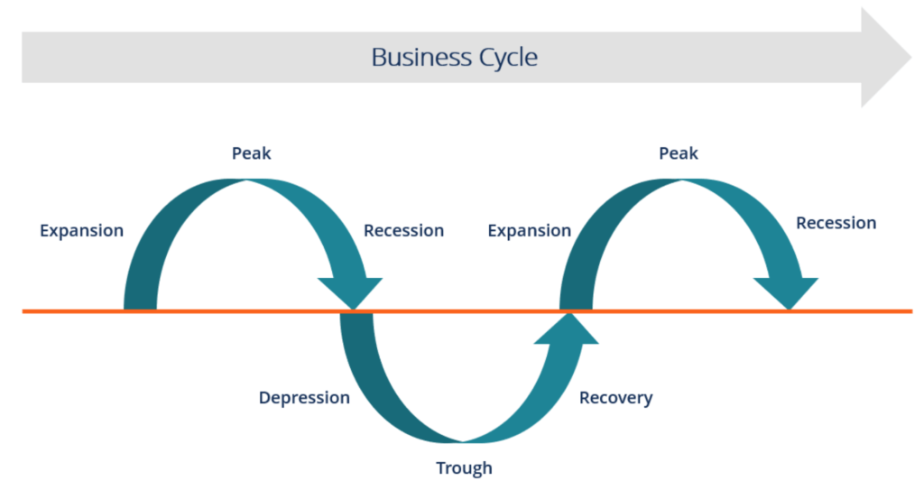

#### **1. Expansion:**

The first stage in the business cycle is expansion. In this stage, there is an increase in positive economic indicators such as employment, income, output, wages, profits, demand, and supply of goods and services. Debtors are generally paying their debts on time, the velocity of the money supply is high, and investment is high. This process continues as long as economic conditions are favorable for expansion.

#### **2. Peak:**

The economy then reaches a saturation point, or peak, which is the second stage of the business cycle. The maximum limit of growth is attained. The economic indicators do not grow further and are at their highest. Prices are at their peak. This stage marks the reversal point in the trend of economic growth. Consumers tend to restructure their budgets at this point.

#### **3. Recession:**

The recession is the stage that follows the peak phase. The demand for goods and services starts declining rapidly and steadily in this phase. Producers do not notice the decrease in demand instantly and go on producing, which creates a situation of excess supply in the market. Prices tend to fall. All positive economic indicators such as income, output, wages, etc., consequently start to fall.

#### **4. Depression:**

There is a commensurate rise in unemployment. The growth in the economy continues to decline, and as this falls below the steady growth line, the stage is called a depression.

#### **5. Trough:**

In the depression stage, the economy’s growth rate becomes negative. There is further decline until the prices of factors, as well as the demand and supply of goods and services, contract to reach their lowest point. The economy eventually reaches the trough. It is the negative saturation point for an economy. There is extensive [depletion](https://corporatefinanceinstitute.com/resources/accounting/depletion/) of national income and expenditure.

#### **6. Recovery:**

After the trough, the economy moves to the stage of recovery. In this phase, there is a turnaround in the economy, and it begins to recover from the negative growth rate. Demand starts to pick up due to low prices and, consequently, supply begins to increase. The population develops a positive attitude towards investment and employment and production starts increasing.

Employment begins to rise and, due to accumulated cash balances with the bankers, lending also shows positive signals. In this phase, depreciated capital is replaced, leading to new investments in the production process. Recovery continues until the economy returns to steady growth levels. This completes one full business cycle of boom and contraction. The extreme points are the peak and the trough.

**Plant Location:**

**Meaning:**

Plant location refers to the process of determining the most suitable geographical site for establishing a manufacturing or production facility. This decision is crucial as it impacts various aspects of a business including operational efficiency, costs, supply chain management and overall competitiveness. Selecting an appropriate location for a plant involves a thorough analysis of multiple factors to ensure the chosen site maximizes the company’s operational efficiency and profitability.

**Importance of selecting appropriate region:**

1. **Cost Efficiency:**
2. Operational Cost: The cost of land, utilities and local taxes can vary significantly between regions. Selecting a location with lower cost reduces the overall expenditure, making the business more competitive.
3. Labor Costs: Wages and salaries differ based on regions. Some areas might offer a skilled workforce at a lower cost which can be an advantage for a business looking to manage labor expenses effectively.
4. **Proximity to Market:**
5. Market Access: Being close to the primary markets reduces transportation costs and delivery time ensuring that products reach customers’ faster and fresher, which is particularly important for perishable goods.
6. Customer Services: Proximity to customer allows for better services, quick response to market changes and enhanced customer satisfaction. It also enables companies to gather market feedback more effectively.
7. **Access to Raw Materials:**
8. Supply Chain Efficiency: Being located near sources of raw materials can reduce transportation cost and lead times. This is especially important for industries reliant on bulky or perishable raw materials.
9. Supplier Relationships: Proximity to suppliers can facilitate better coordination, reliability and partnerships ensuring a steady and timely supply of inputs.
10. **Infrastructure:**
11. Transportation Networks: Adequate infrastructure including roads, railways, ports and airports is essential for efficient movement of goods. A well connected location can enhance logistics and reduce costs.
12. Utilities: Reliable access to water, electricity, gas and other utilities is crucial for smooth operations. Locations with robust infrastructure ensure uninterrupted production process.
13. **Regulatory Environment:**
14. Business Friendly Policies: Regions with favorable business regulations, tax incentives and support for industrial development can attract investments. Understanding local states and national regulations is vital to avoid legal issues and leverage potential benefits.
15. Environmental Regulations: Compliance with environmental laws is essential. Selecting a location with clear and manageable environmental regulations can prevent future legal and operational challenges.
16. **Economic and Political Stability:**
17. Stable Environment: A region with a stable political and economic environment ensures consistent business operations. Uncertainty can lead to risks such as supply chain disruption, increased costs and difficulty in long-term planning.
18. Government Support: Areas with supportive government policies such as grants, subsidies and tax breaks can significantly benefit business reducing operational costs and fostering growth.
19. **Quality of Life:**
20. Employee Satisfaction: Locations offering a high quality of life, including good housing, education, healthcare and recreational facilities can attract and retain talent. Happy and satisfied employees are more productive and loyal.
21. Community Relations: A positive relation with the local community is important. Companies that contribute to local development and maintain good community relations can enhance their reputation and local support.
22. **Technological Ecosystem:**
23. Innovation Hubs: Proximity to technology hubs or research and development centers can foster innovation. Collaboration with local universities, research institutions and technology firms’ can drive technological advancements and improve competitiveness.

Hence, we can say that a strategic and well-informed decision in plant location can lead to enhanced operational efficiency, reduces cost, better market access and ultimately greater profitability and sustainability for the business.